**Classification of EEG signals to identify epileptic seizure using different multi-class Neural Networks**

**Introduction**

Electroencephalography (EEG) is a method that is widely used by neurologists to analyze neurological disorders of patients. The popularity comes from the fact that this method is non-invasive and highly effective.

An EEG is a recording of the brain activity in a particular part of the brain, that outputs a time series, that is a series of numbers which represent the difference in electric potential at a particular point in time. This method of recording electrobiological signals is used in multiple different areas of medicine with the same purpose: to diagnose diseases. (Saeid Sanei, 2007)

The problem with EEG’s lies in the fact that its interpretation is reliant on trained professionals and early diagnosis of neurological diseases is still a difficult task. Automatic analysis of EEG signals is an important step towards making the use of EEG more practical in application and less reliant on trained professionals. (An Automated System for Epilepsy Detection using EEG Brain Signals based on Deep Learning Approach, 2018)

An EEG dataset consists of a 2D (time and channel) matrix of real values**,** which makes it a suitable dataset for machine learning approaches, neural networks in particular, as they have been proven to be more flexible and provide better results than other methods.

Epilepsy is a central nervous system (neurological) disorder in which brain activity becomes abnormal, causing seizures or periods of unusual behavior, sensations, and sometimes loss of awareness. It is characterized by abnormal discharge of brain neurons, which produce the seizure. (Mayo Clinic, 2020)

Recognition of epileptic and non-epileptic EEG signals is a challenging task, because there is a small amount of available data, due to the rare occurrence of seizures. Another problem regarding EEGs is the presence of noise and artifacts in the data, which creates difficulty in the learning process of brain patterns. Inconsistency in seizure morphology among patients also adds to the complexity of the problem. (An Automated System for Epilepsy Detection using EEG Brain Signals based on Deep Learning Approach, 2018)

A lot of different techniques have been used in the past to get higher accuracy on the prediction of the models with great success. Most of these methods focus on the binary classification of the problem (epileptic vs. non-epileptic) and some of them on the ternary classification problem (normal vs. ictal vs. inter-ictal) (An Automated System for Epilepsy Detection using EEG Brain Signals based on Deep Learning Approach, 2018). The purpose of this paper however is to compare different neural network architectures together with feature extraction techniques in order to provide an overview on the performance of each architecture.

**Methods**

**Overview**

The purpose of this paper is to compare the performance of different neural network architectures on the problem of epileptic seizure recognition. This is treated as a multi-label classification problem with 5 classes as provided by the dataset. 3 architectures were tested for this task, each being trained on the raw input signal and on the custom features that were extracted from the signal using discrete wavelet transform.

**Dataset: University of Bonn EEG Dataset**

This dataset contains EEG's from 500 subjects. The recordings were done for 23.5 seconds

and have resulted in 4097 datapoints. This data is divided into 23 chunks which results

in 178 data points in one second. In total there are 11500 rows, each with 178 points.

Each of these rows has been labeled according to the state of the subject (column 'y'), where the labels have the following meaning:

5 - Eyes open, means when they were recording the EEG signal of the brain the patient had their eyes open

4 - Eyes closed, means when they were recording the EEG signal the patient had their eyes closed

3 - The region of the tumor was identified and recording of the EEG activity was taken from the healthy brain area

2 - The EEG recording was taken from the area where the tumor was located

1 - Recording of seizure activity

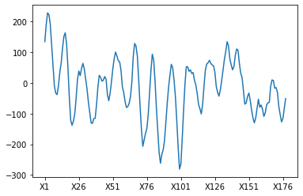

Figure Example of EEG signal from dataset

**Metrics**

The metrics used for evaluating the performance of each model are:

$$Accuracy= \frac{(TP+TN)}{(TP+TN+FP+FN)}$$

$$Sensitivity=\frac{TP}{TP+FN}$$

$$Specificity=\frac{TN}{TP+FN}$$

$$Loss=-\sum_{i=0}^{C-1}{y_{i}*\log{(x_{i})}}$$

Where: TP – True Positives, TN – True Negatives, FP – False Positives, FN – False Positives,

C – number of classes, y – target value, x – predicted value.

For the loss function the average loss for the test data is compared.

**10-fold cross validation**

Out of the 3 models, 2 were tested using 10-fold cross validation. By using this method we can get a more accurate representation of the models performance on another dataset. In this method the dataset is divided into 10 parts (more generally k), and then 1 part is chosen as the test data. The model is trained on the remaining 9 parts and the performance of the model for that particular “fold” is compared against the test data. This process is repeated until all parts have been chosen as test data. The final metrics are the averages of the metrics from each fold. For each fold the model is trained for 50 epochs.

**Feature extraction**

For feature extraction the discrete wavelet transform (DWT) method was used using the wavelets Daubechies 6, Symlets 6 and Coiflets2 as their output has the same length when applied to the same signal. When applying these wavelets (1 level deep) the signal is decomposed into 2 signals of equal length one being the approximate coefficients which result from applying the low pass filter from the wavelet and the other one being the detailed coefficients which result from applying the high pass filter from the wavelet. (Hojiat Adeli, 2010) Whenever another wavelet was used to filter the data it will be mentioned.

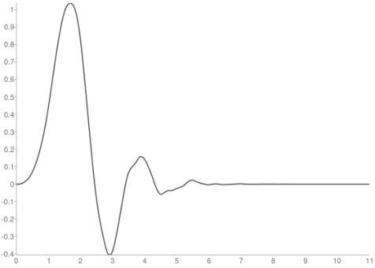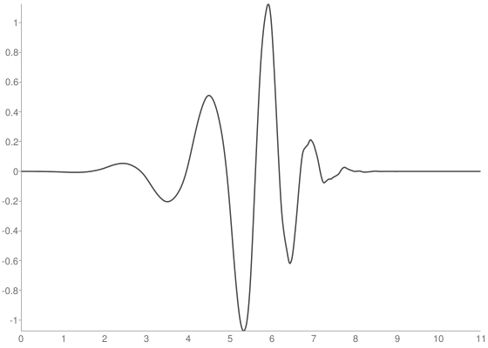

Figure Daubechies 6 Low Pass Filter Figure Daubechies 6 High Pass Filter

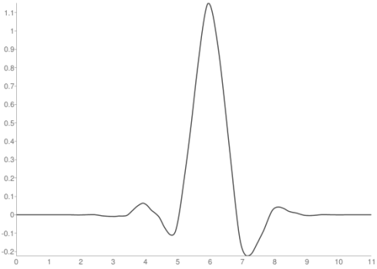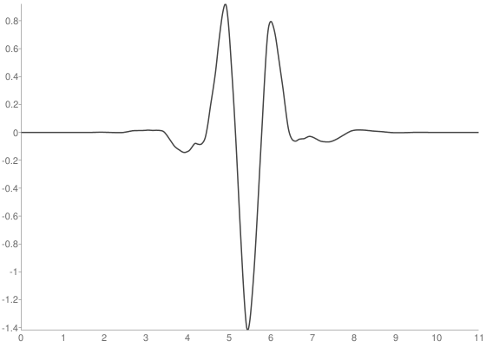

Figure Symlets 6 Low Pass Filter Figure Symlets 6 High Pass Filter

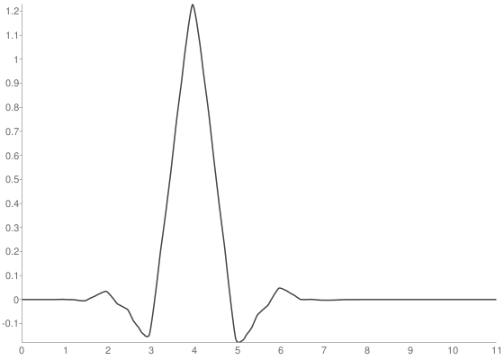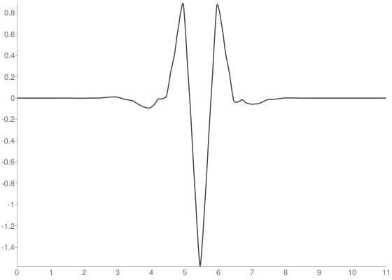

Figure Coiflets 2 Low Pass Filter Figure Coiflets 2 High Pass Filter

Example of signal decomposition after applying DWT:

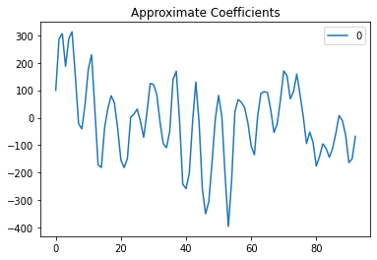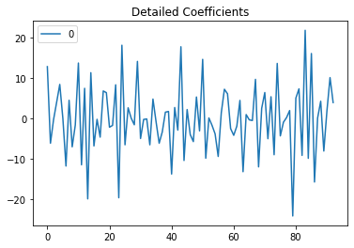

**General Designs**

These design features appear in each model. The chosen loss function for this classification task was categorical cross entropy as the output from each model is a vector of length 5, denoting the probability of each class. As for the optimizer Adam with default parameters was chosen, because it appeared to decrease the loss faster than other optimizers. For the final classification each model uses 2-3 fully connected layers, where the last layers uses the softmax activation function and the others use sigmoid.

**Model 1 – Fully Connected Neural Network**

The first model consists of a sequence of fully connected (also called dense) layers. There are 3 dense layers with the following number of neurons: 300, 100, 20, each layer using sigmoid as activation function. After these layers there is a dropout layer with 50% chance. This is used so that model does not overfit the test data. The final layer is the output layer and it is a dense layer with 5 neurons with sofmax as its activation function.

In the case where raw signal is passed to the model, the input consists of a 1 dimensional vector of length 178. Using this as input the model has a 50% average accuracy and an average loss of 1.193. When filtering the input only the detailed coefficients from the Daubechies 6 wavelet transformation were passed to the model. This however decreased the model’s average accuracy by 2%, so the accuracy in this case is 48% and the average loss is 3.017.

**Model 2 – Convolutional Neural Network**

This model is composed of 3 1D convolutional layers, each having different filter number and different kernel sizes. All convolutional layers use ReLU (rectified linear unit) activation function and use a stride of 1. The first convolution layer has 32 filters with a kernel size of 15, the second has 16 filters with kernel size 10 and the last convolutional layer has 8 filters with kernel size of 5. After these convolution layers a 1D max pooling layer is applied with a pool size of 2 in order to reduce the dimensions of the output from the convolutional layers. The reduced output is then flattened in order to be passed to the classification part of the model, which consists of 2 dense layers, separated by a dropout layer with 50% bias. The first dense layer has 40 neurons and uses sigmoid activation while the other one being the output layer has 5 neurons with softmax activtation.

The input layer for this model when using raw signals is also 1D vector of length 178, that means that the input for the first convolutional layer is 1 channel with 178 datapoints. The average accuracy in this case is 74%, having a sensitivity of 95% for class 1 which denotes seizure activity. When filtering the input into 6 signals using DWT with each of the above mentioned wavelets the accuracy drops to about 48% which and the sensitivity for each class is much lower. The average loss in this case is 1.132, while the raw signal input gives a loss of only 0.549.

**Model 3 – Recurrent Neural Network**

This model has the least amount of layers compared with the other ones. This model, besides input and classification layer has only a GRU layer with 64 units. The GRU layer uses tanh as the activation function and sigmoid for the recurrent activation. The classification is the same as in all other cases and uses the same activations.

As this model takes a long time to train, only one fold was used to test the model. The model was trained for 50 epochs and had the following result: When not filtering the signal the model achieved accuracy of 71% and a sensitivity of over 90% in classes 1 (seizure activity), 4 (eyes closed - normal) and 5(eyes open - normal), which is higher than any other model. The same decrease in accuracy appeared here as well when first filtering out the input data. The filtered data consists of 6 vectors of the same size, which represent the output from the DWT of the wavelets: Daubechies 6, Symlets 6 and Coiflets2. The accuracy in this case was 66%.

**Results**

To measure the performance of each model, accuracy, loss were taken into account together with sensitivity and specificity for each of the 5 classes that were predicted. The fully connected (dense) neural network and the convolutional neural network were trained for 50 epochs using 10-fold cross validation, while the recurrent neural network was trained for 50 epochs using only 1 fold.

The dense neural network had the most number of learnable parameters and had the following performance: the average accuracy when passing raw signal into the network was 50.98%, while the average accuracy for the filtered signal was 48.76%. This method had trouble differentiating between class 4 and 5 (eyes open – 5, eyes closed - 4) and between the inter ictal classes (2 and 3) in which the patient had a brain tumor but there was no seizure detected. The sensitivity for these classes varies and goes as low as 36% for class 2 and 58% for class 4. Best sensitivity was obtained by class 1 (seizure) with a value of 71%, comparable to the sensitivity when the input was filtered – 70%. When filtering the signal accuracy dropped by a little, but the sensitivity for classes 2, 4, 5 improved, while the sensitivity for class 3 dropped drastically. In terms of specificity the best performing class was class 1, about 92% for both input types.

The convolutional neural network yielded the best results out of all methods with an accuracy of 74.42% with raw signal and 48.59% when filtering the signal. In the case of raw signal input, the sensitivity of all classes but one was above 60%, with the highest being class 1 with 95%. The lowest sensitivity was for class 2 (EEG taken from the area where tumor is located): 46%. The rest of the classes had a fairly good sensitivity of around 80%. Specificity using this method was also better, all classes having a specificity of around 90%. Filtering the input signal didn’t provide better metrics as the accuracy dropped significantly together with the sensitivity, especially for the seizure class: 49%. For all other classes the result is similar, a drop in accuracy.

The recurrent neural network model was the only one that wasn’t trained using 10-fold cross validation, so results might differ slightly in reality or when using another data set. This model had the least number of trainable parameters, but it did yield decent results. In the case of raw signal, the average accuracy was 71.58% and for the filtered input it was 66.36%. As with the other cases the best sensitivity is for class 1 being around 90% for both input methods together with the specificity of around 98%. This method struggled the least when predicting classes 4 and 5 (eyes closed, eyes open), both classes having the same sensitivity for both input methods and that is 78%. The worst metrics for this method was the sensitivity for classes 2 and 3, which was around 50% for both input types.

|  |  |  |  |  |  |  |
| --- | --- | --- | --- | --- | --- | --- |
|  | FCNN | FCNN + DWT | CNN | CNN + DWT | RNN | RNN + DWT |
| Avg. Loss | 1.19308 | 3.01702 | 0.54993 | 1.13221 | 0.61629 | 1.14335 |
| Avg. Accuracy(%) | 50.9826 | 48.7652 | 74.4260 | 48.5913 | 71.5826 | 66.3652 |
| Sensitivity Class 1(%) | 71 | 70.21 | 95.52 | 49.21 | 96.04 | 87.97 |
| Sensitivity Class 2(%) | 36 | 50.73 | 46.30 | 44.95 | 45.84 | 51.55 |
| Sensitivity Class 3(%) | 44.39 | 21.73 | 65.52 | 41.17 | 59.04 | 50.88 |
| Sensitivity Class 4(%) | 58.21 | 50.82 | 79.73 | 72.52 | 78.53 | 78.36 |
| Sensitivity Class 5(%) | 45.30 | 50.30 | 85.04 | 35.08 | 78.01 | 62.23 |
| Specificity Class 1(%) | 92.45 | 92.93 | 99.14 | 95.74 | 99.08 | 97.02 |
| Specificity Class 2(%) | 84.26 | 86.51 | 91.84 | 82.5 | 91.16 | 86.59 |
| Specificity Class 3(%) | 85.18 | 88.05 | 87.09 | 86.73 | 87.97 | 88.53 |
| Specificity Class 4(%) | 93.09 | 88.86 | 97.27 | 83.86 | 94.53 | 93.57 |
| Specificity Class 5(%) | 83.72 | 79.58 | 92.63 | 86.88 | 91.77 | 92.08 |

**Conclusion**

The model with the best results was the convolutional model, using raw signal as input. This method had the highest accuracy and lowest loss of all the other methods. Even though the accuracy is a little below 75%, given the difficulty of the prediction task it’s a decent accuracy. The biggest problem for all models were the differences between class 2 and 3, and class 4 and 5 respectively, as the signals are not easily distinguishable. Oddly enough, all models performed worse when the signal was filtered as opposed to unfiltered signal. This may be because of the choice of wavelets when using discrete wavelet transform or because this filtering method is not suited for this task. The dense model had the slightest difference in accuracy when changing the input method and in my opinion is not worth pursuing any further, as any other slight tweaks to the model might not yield a better result. The recurrent model stands in between the other 2 as it had decent accuracy and the input didn’t affect the accuracy as drastically as with the convolutional network. It’s important to also take into consideration the fact that the recurrent model was trained using only one fold and that its performance might vary.

This prediction task is over all quite a difficult one as there are major differences between some classes and only minor ones between others, as shown by the metrics of each model. Using different filtering techniques and other manipulations of the time series might improve the results. Another important aspect is the fact that no artifact removal was done on the dataset and that the dataset is limited to only 500 patients, so the same EEG from one patient was treated as multiple inputs for the networks, in order to have enough data for training.

**References**

*A Deep Learning Approach for Parkinson’s Disease Diagnosis from EEG Signals.* **Shu Lih Oh, Yuki Hagiwara, U Raghavendra, Rajamanickam Yuvaraj, N Arunkumar, Murugappan M, U Rajendra Acharya. 2018.** 2018.

*An Automated System for Epilepsy Detection using EEG Brain Signals based on Deep Learning Approach.* **Ihsan Ullah, , Muhammad Hussain, Emad-ul-Haq Qazi, Hatim Aboalsamh. 2018.** 2018.

*Artificial Intelligence Techniques for Automated Diagnosis of Neurological Disorders.* **U. Raghavendra, U. Rajendra Acharya, Hojjat Adeli. 2019.** 2019.

*Classification of EEG Signals Based on Pattern Recognition Approach.* **Hafeez Ullah Amin, Wajid Mumtaz, Ahmad Rauf Subhani, Mohamad Naufal Mohamad Saad, Aamir Saeed Malik. 2017.** s.l. : ResearchGate, 2017.

*Deep learning for electroencephalogram (EEG) classification tasks: a review.* **Alexander Craik, Yongtian He, Jose L Contreras-Vida. 2019.** 2019, Journal of Neural Engineering.

*Epilepsy EEG Signal Classification Algorithm Based on Improved RBF.* **Dongmei Zhou, Xuemei Li. 2020.** 2020.

**Hojiat Adeli, Samanwoy Ghosh-Dastidar. 2010.** Time-Frequency Analysis: Wavelet Transforms. *Automated EEG-Based Diagnosis of Neurological Disorders.* 2010.

**Mayo Clinic. 2020.** Epilepsy. *mayoclinic.org.* [Online] 2020. https://www.mayoclinic.org/diseases-conditions/epilepsy/symptoms-causes/syc-20350093.

**Peng, Roger D. 2020.** A Very Short Course on Time Series Analysis. *bookdown.org.* [Online] 2020. https://bookdown.org/rdpeng/timeseriesbook/.

**Saeid Sanei, J.A. Chambers. 2007.** Fundamentals of EEG Signal Processing. *EEG Signal Processing.* 2007.